**1. Determine how many books are in the Cooking category.**

SELECT COUNT(*)

FROM books

WHERE category = 'COOKING';

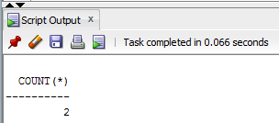

**2. Display the number of books with a retail price of more than $30.00.**

SELECT COUNT(*)

FROM books

WHERE retail > 30;

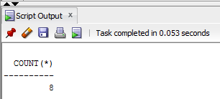

**3. Display the most recent publication date of all books sold by JustLee Books.**

SELECT MAX(pubdate)"Most Recent PubDate"

FROM books;

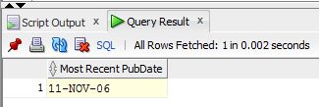

**4. Determine the total profit generated by sales to customer 1017.**

**Note: Quantity should be reflected in the total profit calculation.**

SELECT SUM((retail-cost)*quantity)"1017 Total Profit"

FROM orders JOIN orderitems USING(order#) JOIN books USING(isbn)

WHERE customer# = 1017;

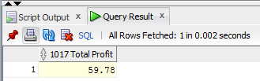

**5. List the retail price of the least expensive book in the Computer category.**

SELECT MIN(retail)"Least Expensive"

FROM books

WHERE category = 'COMPUTER';

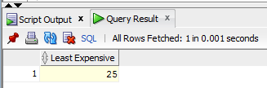

**6. Determine the average profit generated by orders in the ORDERS table.**

**Note: The total profit by order must be calculated before finding the average profit.**

SELECT ROUND(AVG(SUM((retail-cost)*quantity)),2)"AVG Orders Profit"

FROM orders JOIN orderitems USING(order#) JOIN books USING(isbn)

GROUP BY order#;

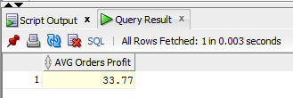

**7. Determine how many orders have been placed by each customer. Do not include in the results any customer who hasn’t recently placed an order with JustLee Books.**

SELECT customer#, COUNT(*)"Orders Placed"

FROM orders

GROUP BY customer#;

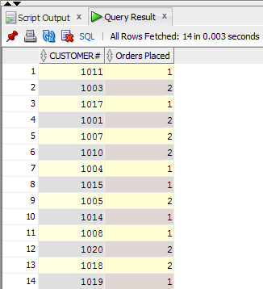

**8. Determine the average retail price of books by publisher name and category. Include only the categories Children and Computer and the groups with an average retail price greater than $50.**

SELECT name, category, AVG(retail) as "Average"

FROM books JOIN publisher USING(pubid)

WHERE category IN('COMPUTER', 'CHILDREN')

GROUP BY name, category;

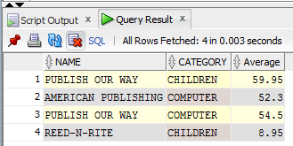

**9. List the customers living in Georgia or Florida who have recently placed an order totaling more than $80.**

SELECT DISTINCT firstname, lastname, order#

FROM customers JOIN orders USING(customer#) JOIN orderitems USING(order#) JOIN books USING(isbn)

WHERE (state = 'FL' or state = 'GA')

GROUP BY order#, firstname, lastname

HAVING SUM(retail*quantity)>80;

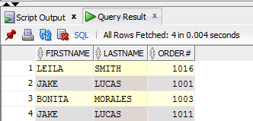

**10. What’s the retail price of the most expensive book written by Lisa White?**

SELECT MAX(retail)"Most Expensive Book"

FROM books JOIN bookauthor USING(isbn) JOIN author USING(authorid)

WHERE lname = 'WHITE'

AND fname = 'LISA';

